**2 - ServiceNow Platform Overview**

**Now Platform Architecture -** The Now Platform is a cloud-based Application Platform as a Service (APaaS). It provides the necessary computer resources and a platform for building custom solutions. It offers a strong collection of applications and workflows to handle typical business processes. All applications, whether out-of-the-box (OOB) or custom-made, for the whole enterprise are supported by a single, unified data model and database.

**Application and Workflows -** The Now Platform's applications are divided into four main categories:

IT Workflows - Includes 79 applications to support internal IT functions.

Employee Workflows - Includes 43 applications aimed at meeting employee needs.

Customer Workflows - Includes 93 applications focused on customer-related functions.

Creator Workflows - Includes 23 applications designed to help with ServiceNow platform development and operations.

When you purchase an instance, the following resources are enabled and secured:

Enterprise Cloud - Uses a multi-instance architecture where each instance has its own platform and database.

Availability and Redundancy - Ensured at every layer, including devices, power, and network resources.

Backups and Security - Provides four weekly full data backups and six days of daily differential backups.

Domain Separation - Allows the platform to organize data, processes, and administrative tasks into logical groupings called domains.

**User Interfaces -**  The ServiceNow platform offers three user interfaces:

Now Platform UI - Best for desktop and laptop use, accessible through a web browser and the instance URL.

ServiceNow Mobile Apps - This is best used on mobile devices and can be installed via device’s app stores. The applications are ServiceNow Agent which targets fulfilling requests, Now Mobile which is built for the needs of employees and ServiceNow On-boarding that targets the newly hired employees.

Service Portals - A user-friendly, self-service portal with widgets, accessible via a web browser and a special URL.

**Role-based Access -** The main components are:

User - A person who has access to an instance. They are usually part of one or more groups and can have multiple roles.

Groups - A collection of users with a common purpose who need access to similar data. A group can have multiple roles.

Role - A set of permissions that can be given to an individual, a group, or another role. A single role can include multiple roles.

**User Authentication -** When a user tries to log into an instance, ServiceNow verifies their identity and grants access to functions and data based on their groups and roles. The methods used include:

Local Database Authentication

External Single Sign-On (SSO)

LDAP

Multi-Factor Authentication

OAuth 2.0

Digest Token

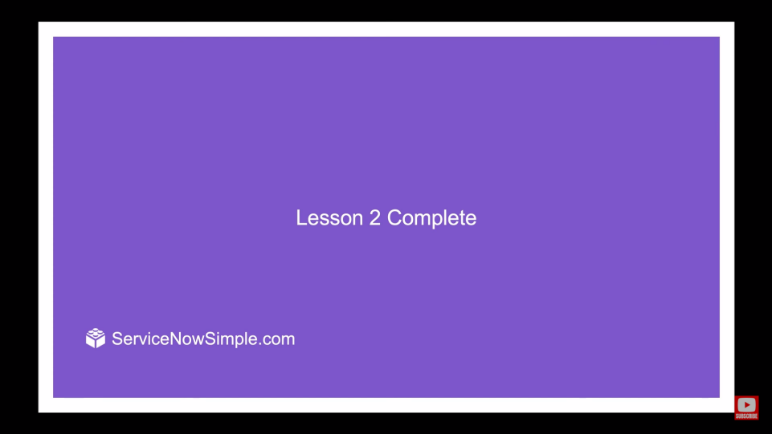

ANANYA CHOUDHARY